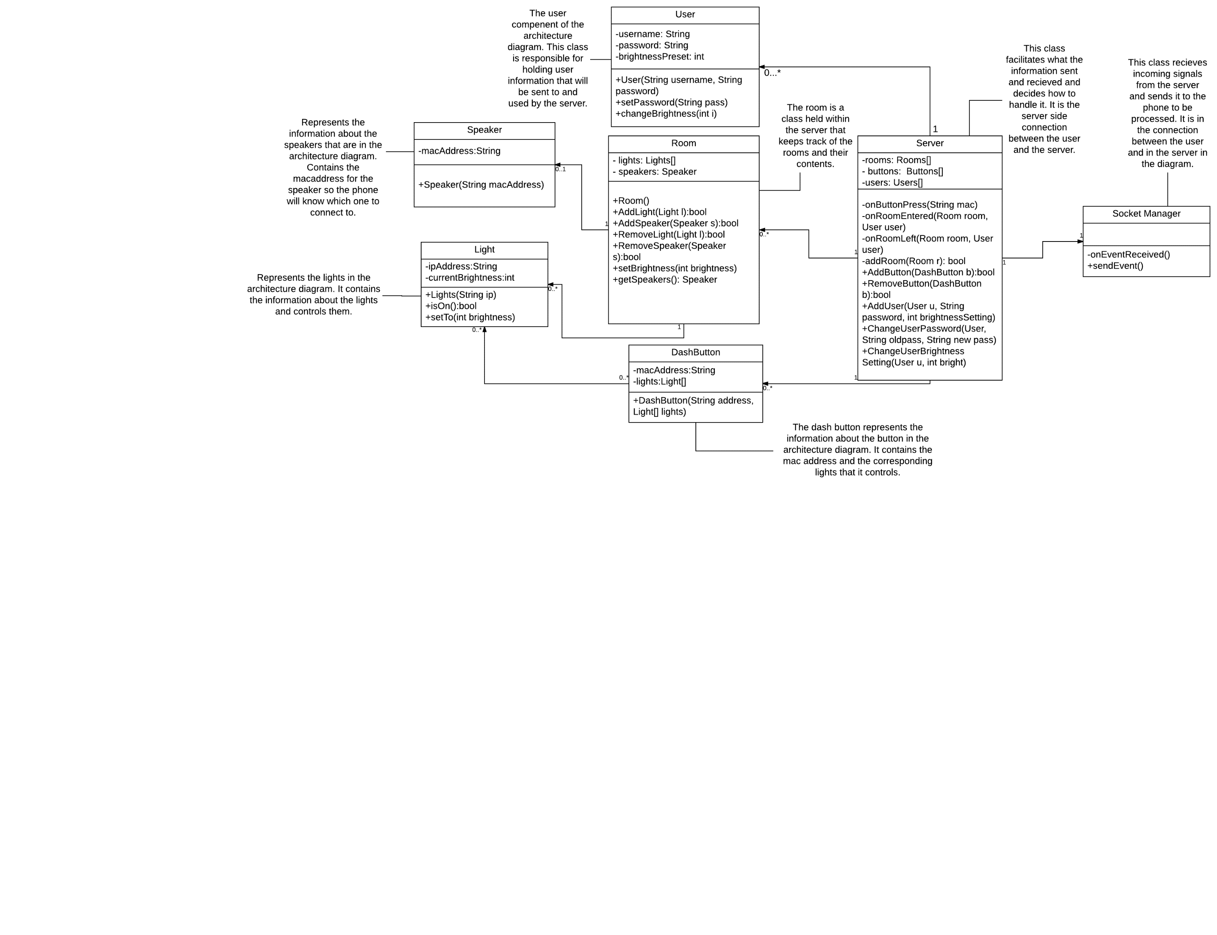Server Side Class Diagram:

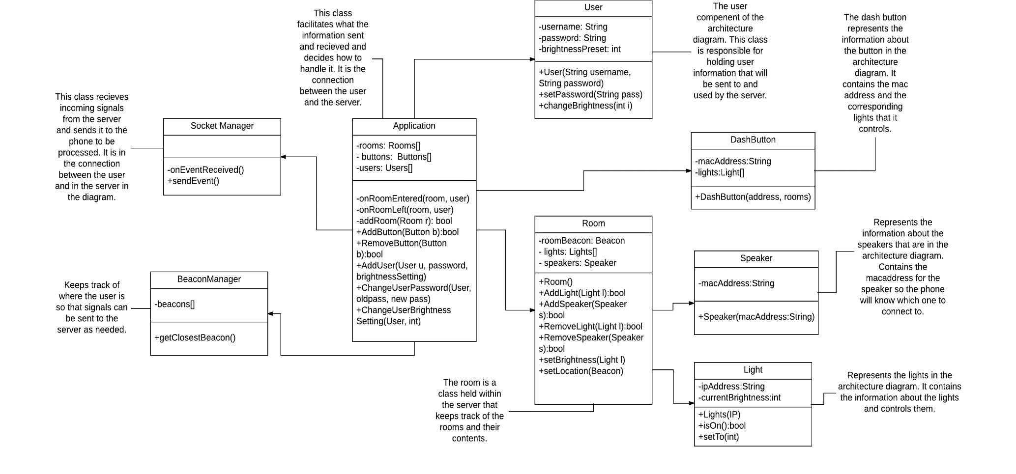Android App Class Diagram:

Light Driver:

The structure of the light driver code will not use an object-oriented design due to its simplicity. The driver will instead use an event driven design via socket.io events.